Ali Husnain Shah

finger print Science
Answer Outline

- INTRODUCTION:
The method of identifying criminals by means of their digital or palmar prints, known as the finger print system, which was discovered by Sir William J Hershel
A finger print means an impression made by the ball of a finger. The finger print system also known as dactylography

- DEFINITION:
A finger print means an impression made by the ball of the finger.

- Evolution of finger print science:
The science of finger print was known in ancient Assyria and used for the purpose of identification in 700 AD. The chines police were using in the 13th century.

- Introduced In Sub Continental:
It was introduced in Hugli District of Bengal in 1877 by Sir William J. Herschel.
- When it was systematized:

- Types of finger prints science:
Following are the types of finger prints.
- Arch____define:
The ridges run from one side of the print to the other and, as the name implies in arch like fashion.
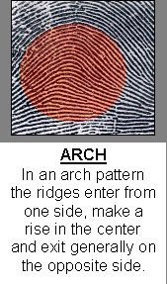

- Loops____define:
The ridges about the center of the print arrange themselves somewhat in the form of a hairpin, the ends of which point more or less in a downward slanting direction.
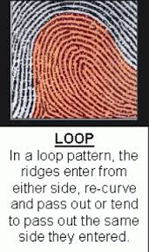

- Whorl____define:
The ridges from a more intricate pattern than the arch and loops, the circular design of the ridge groupings is conspicuous. The ridges may take clockwise or anti-clockwise turn.
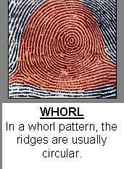
- Compound:
This pattern consists of two or more of the proceeding pattern, there are always two deltas.

- Method of taking fingerprint impression:
- Plain impression:
- Rolled impression:

- Important tips for obtaining fingerprint impression:
(See for more details. page 55 of Parikh’s textbook of medical jurisprudence and toxicology)

- Finger prints of following persons:
- Fingerprint of a dead body:
- Faint and indivisible finger print
- Person suffering from infection:

- Importance of fingerprints:
- Identification:
- Conviction of accused:
- Protection against fraud:
- In criminal proceeding:
- Prevention against perjury

- Conclusion:

